Proposal to English 2221: Introduction to Shakespeare, Race, and Gender

English 2221: Shakespeare, Race, and Gender. The Department of English proposes a course that will provide students with an opportunity to study the historical roots of our ideas about race and gender by way of Shakespeare and the culture in which he wrote. Emphasis will be on those plays in which Shakespeare engages directly with gendered and racial outsiders – among them Othello, The Merchant of Venice, Titus Andronicus, The Taming of the Shrew. Shakespeare’s formulations of issues of race and gender are products of a time when both categories were undergoing significant conceptual development, and Shakespeare’s ways of imagining the consequences of this turbulence continue to resonate in our own culture, as evidenced by the persistent popularity of Shakespeare in the classroom, on the stage, and on screen. While the emphasis will in all iterations remain squarely on Shakespeare’s texts, instructors would be able supplement this reading with contemporary texts that shed light on the emerging discourses of racial and gender difference.

This course will satisfy the Expected Learning Outcomes for the Race, Ethnic, and Gender Diversity Foundation:

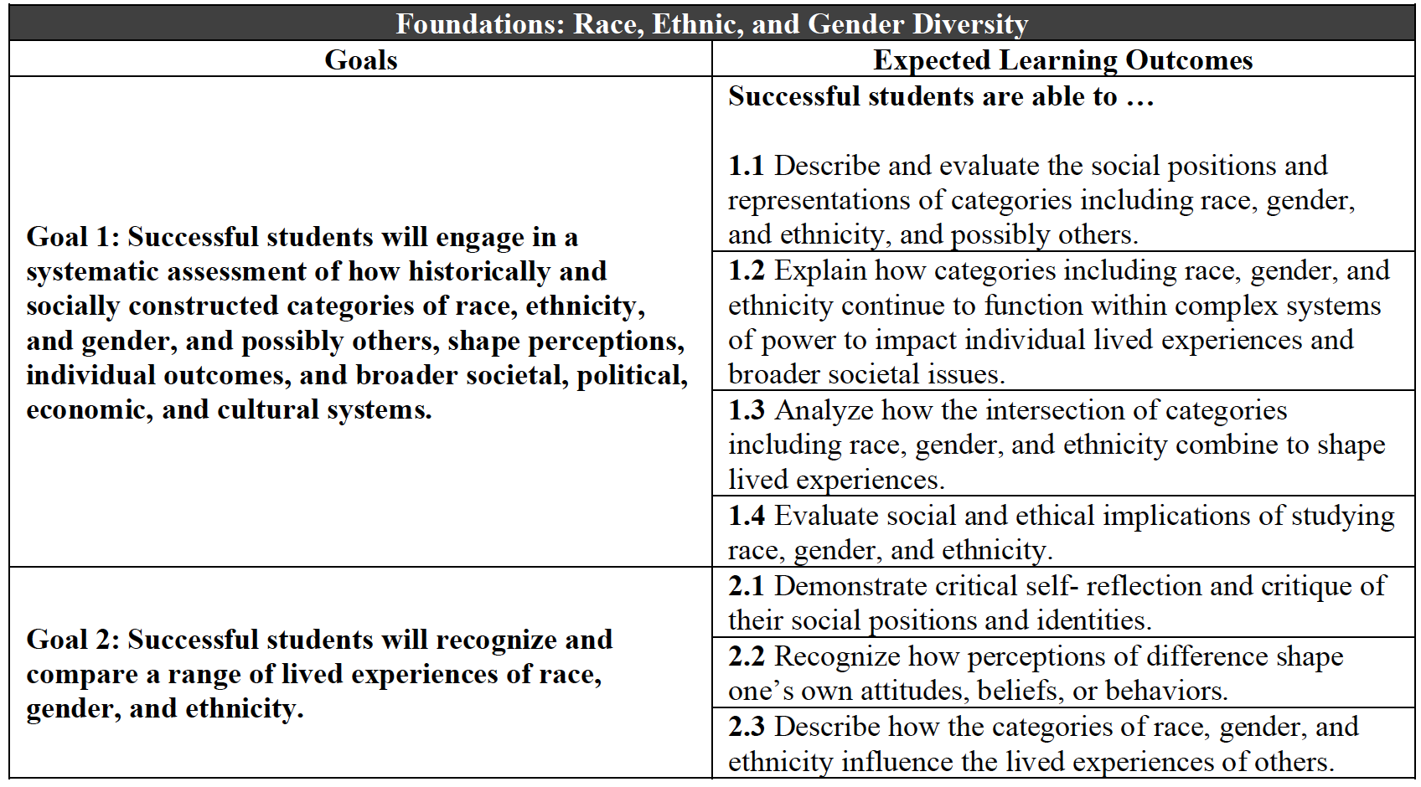

Instructors who might teach this course include Professors Amrita Dhar, Alan Farmer, Hannibal Hamlin, Jennifer Higginbotham, Christopher Highley, Elizabeth Kolkovich, Sarah Neville, and Luke Wilson.

English 2221: Shakespeare, Race, and Gender
Sample Syllabus
Elizabeth Kolkovich

Course Description: How has the past shaped our present? What are the historical roots of our ideas about race and gender? We will examine these questions as we study identity in the literature and culture of Shakespeare. We will analyze five plays, which we will seek to understand in their historical moment and our own. To do so, we will supplement our reading of the plays with film clips, historical documents, and modern essays. As we encounter characters who label themselves outsiders because of their gender, race, or other factors, we will also think more deeply about the diverse people and perspectives that comprise our own culture.

At the course’s end, you will be able to:
- Understand the plot, characters, and themes of five representative Shakespeare plays, as well as some details about Shakespeare’s culture.
- Compare ideas about race and gender in Shakespeare’s time to those of our own, as well as your own values, beliefs, and actions with those of others.
- Value multiple perspectives and diverse identities.
- Read with greater confidence, think critically, and ask good questions.
- Enjoy Shakespeare for the rest of your life.

General Education Expected Learning Outcomes:

Required Texts (available through the OSU Bookstore):
Titus Andronicus (Folger Shakespeare Library)
The Taming of the Shrew (Bedford Texts and Contexts)
The Merchant of Venice (Folger Shakespeare Library)
Othello (Bedford Texts and Contexts)
The Tempest (Folger Shakespeare Library)

Other Required Materials:
Digital texts and films at our course website, carmen.osu.edu
Paper notebook or digital file for note-taking

Course Requirements:
Participation and engagement 10%
Reading questions 20%
Quizzes (4 @ 5% each) 20%
Essays (2 @ 15% each) 30%
Take-home final 20%

Participation and Engagement: Like Shakespeare’s theater, this course is a collaborative production; your thoughtful participation is essential to its success. There are many ways to participate and engage: prepare for class by reading carefully, arrive on time, listen actively, ask questions, share reactions and beginning ideas, work together in small groups, show respect for classmates, visit office hours, contribute to online discussions, and do small in-class writing tasks conscientiously. If you have difficulty talking in class, you can earn extra points by emailing me your thoughts after class or adding an observation or question to the day’s reading questions. I evaluate participation according to the following scale (including +/- grades):

A = Daily, thoughtful participation. Student attends regularly, comes to class prepared and with the text, arrives on time and stays for the full class, stays alert and engaged, completes homework effectively and on time, and visits my office hours or the Writing Center when needed or desired. Student ideally talks at least once a class but might alternately contribute in non-verbal or written ways.
B = Frequent to occasional participation. Student is partially engaged and alert but misses more classes and shows less dedication.
C = Participation only when called on, often distracted, some attendance problems.
D = Lack of preparation, refusal to participate even when called on, attendance problems.
E = No preparation for class, severe attendance problems.

Reading Questions: For every class session, I will assign a short number of questions, and you will submit brief answers on Carmen. These questions guide you through the reading and help you prepare for class. Answering them should take no longer than 5-15 minutes after you finish the day’s reading. There are twenty required submissions. For each completed set, you earn one point. For partially complete submissions, you earn ½ point. No late submissions accepted.

Quizzes: Five announced quizzes spaced evenly throughout the term will test your knowledge of key terms, comprehension, close reading, and critical thinking. They happen at the beginning of class, so be on time! I will drop your lowest quiz grade.

Essays: To practice the skills you need to understand and enjoy Shakespeare, you will write two short essays (2-4 pages each). The first is a textual analysis in which you examine a single passage closely; the second is a performance analysis that requires you to watch and write about a live or filmed version of one of our plays.

Take-home final exam: In lieu of an in-class exam, you will show off your knowledge by submitting an independent final project. Options include a comparative essay or creative piece.

HOW TO PREPARE FOR CLASS

- Read the assignment listed in the syllabus before class. As you read, take notes somewhere you can access in class: the margins of your book, a notebook, or a digital file. Use footnotes to help you understand the language, and look up additional unfamiliar words in the Oxford English Dictionary (see our Carmen page for a link).
- Read the reading questions on Carmen. Take 5-15 minutes to answer them, and submit your answers before class begins.
- Bring the reading to class, and come ready to discuss it. Come to every class with at least one thing to contribute: a question, passage, or observation to discuss.

CLASS SCHEDULE

Please note: Assignments and due dates are subject to change based on class needs. Carmen = our course website at carmen.osu.edu.

Tu 1/7 Introduction to the course.
Th 1/9 Gender in Shakespeare’s time and ours. McDonald, “Men and Women: Gender, Family, Society”; Solnit, “Men Explain Things to Me” (Carmen).

Tu 1/14 Race in Shakespeare’s time and ours. Hall, “Introduction” from Things of Darkness; Delgado and Stefancic, Introduction to Critical Race Theory (Carmen).
Th 1/16 Titus Andronicus, Act 1. Excerpts from historical texts in Othello Bedford Texts and Contexts, ed. Hall.

Tu 1/21 Titus Andronicus, Act 2.
Th 1/23 Titus Andronicus, Acts 3-4.

Tu 1/28 Titus Andronicus, Act 5. Quiz 1.
Th 1/30 Titus Andronicus. Loomba, “Wilderness and Civilization in Titus Andronicus” (Carmen).

Tu 2/4 The Taming of the Shrew, Act 1.
Th 2/6 The Taming of the Shrew, Act 2.

Tu 2/11 The Taming of the Shrew, Act 3-Scene 4.2.
Th 2/13 The Taming of the Shrew, Scene 4.3-Act 5. Quiz 2.

Tu 2/18 The Taming of the Shrew. Excerpts from historical texts in Bedford Texts and Contexts, ed. Dolan (Carmen).
Th 2/20 The Merchant of Venice, Act 1. Essay 1 due by Friday.

Tu 2/25 The Merchant of Venice, Act 2.
Th 2/27 The Merchant of Venice, Act 3.

Tu 3/3 The Merchant of Venice, Acts 4-5. Quiz 3.
Th 3/5 The Merchant of Venice. Frank, “The Merchant of Venice Perpetuates Vile Stereotypes”; NPR Code Switch Podcast, “All That Glisters is Not Gold” (Carmen).

SPRING BREAK

Tu 3/17 Othello, Act 1; excerpts from “Contexts” section.
Th 3/19 Othello, Acts 2-3.

Tu 3/24 Othello, Act 4.
Th 3/26 Othello, Act 5. Quiz 4.

Tu 3/31 Othello. Quarshie, “Playing Othello”; Smith, “We Are Othello.” Recommended: Shakespeare Unlimited Podcast, “Othello and Blackface” (Carmen).
Th 4/2 The Tempest, Act 1. Essay 2 due by Friday.

Tu 4/7 The Tempest, Act 2.
Th 4/9 The Tempest, Acts 3-4.

Tu 4/14 The Tempest, Act 5. Quiz 5.
Th 4/16 The Tempest. Gonsalez, “Caliban Never Belonged to Shakespeare” (Carmen).

Take-home final exam due to Carmen Assignments by our scheduled final exam time (Early submissions welcome; NO LATE PAPERS ACCEPTED).

Important Information:

Ohio State’s academic integrity policy
Academic integrity is essential to maintaining an environment that fosters excellence in teaching, research, and other educational and scholarly activities. Thus, The Ohio State University and the Committee on Academic Misconduct (COAM) expect that all students have read and understand the university’s Code of Student Conduct, and that all students will complete all academic and scholarly assignments with fairness and honesty. Students must recognize that failure to follow the rules and guidelines established in the university’s Code of Student Conduct and this syllabus may constitute “Academic Misconduct.”

The Ohio State University’s Code of Student Conduct (Section 3335-23-04) defines academic misconduct as: “Any activity that tends to compromise the academic integrity of the university or subvert the educational process.” Examples of academic misconduct include (but are not limited to) plagiarism, collusion (unauthorized collaboration), copying the work of another student, and possession of unauthorized materials during an examination. Ignorance of the university’s Code of Student Conduct is never considered an excuse for academic misconduct, so we recommend that you review the Code of Student Conduct and, specifically, the sections dealing with academic misconduct.

It is the responsibility of the Committee on Academic Misconduct to investigate or establish procedures for the investigation of all reported cases of student academic misconduct. The term “academic misconduct” includes all forms of student academic misconduct wherever committed; illustrated by, but not limited to, cases of plagiarism and dishonest practices in connection with examinations. Instructors shall report all instances of alleged academic misconduct to the committee (Faculty Rule 3335-5-487). For additional information, see the Code of Student Conduct http://studentlife.osu.edu/csc/.

If we suspect that a student has committed academic misconduct in this course, we am obligated by university rules to report my suspicions to the Committee on Academic Misconduct. If COAM determines that you have violated the university’s Code of Student Conduct (i.e., committed academic misconduct), the sanctions for the misconduct could include a failing grade in this course and suspension or dismissal from the university.
If you have any questions about the above policy or what constitutes academic misconduct in this course, please contact me.
Other sources of information on academic misconduct (integrity) to which you can refer include:
- The Committee on Academic Misconduct web pages (COAM Home)
- Ten Suggestions for Preserving Academic Integrity (Ten Suggestions)
- Eight Cardinal Rules of Academic Integrity (www.northwestern.edu/uacc/8cards.htm)

Copyright disclaimer
The materials used in connection with this course may be subject to copyright protection and are only for the use of students officially enrolled in the course for the educational purposes associated with the course. Copyright law must be considered before copying, retaining, or disseminating materials outside of the course.

Statement on Title IX

All students and employees at Ohio State have the right to work and learn in an environment free from harassment and discrimination based on sex or gender, and the university can arrange interim measures, provide support resources, and explain investigation options, including referral to confidential resources.
If you or someone you know has been harassed or discriminated against based on your sex or gender, including sexual harassment, sexual assault, relationship violence, stalking, or sexual exploitation, you may find information about your rights and options at titleix.osu.edu or by contacting the Ohio State Title IX Coordinator at titleix@osu.edu. Title IX is part of the Office of Institutional Equity (OIE) at Ohio State, which responds to all bias-motivated incidents of harassment and discrimination, such as race, religion, national origin and disability. For more information on OIE, visit equity.osu.edu or email equity@osu.edu.

Your mental health

As a student you may experience a range of issues that can cause barriers to learning, such as strained relationships, increased anxiety, alcohol/drug problems, feeling down, difficulty concentrating and/or lack of motivation. These mental health concerns or stressful events may lead to diminished academic performance or reduce a student's ability to participate in daily activities. The Ohio State University offers services to assist you with addressing these and other concerns you may be experiencing. If you find yourself feeling isolated, anxious or overwhelmed, please know that there are resources to help: ccs.osu.edu. You can reach an on-call counselor when CCS is closed at (614) 292-5766 and 24 hour emergency help is also available through the 24/7 National Prevention Hotline at 1-(800)-273-TALK or at suicidepreventionlifeline.org. The Ohio State Wellness app is also a great resource available at go.osu.edu/wellnessapp.

Academic Support Services and Resources
For support on matters relating to scheduling courses, paying for tuition, and viewing grades at the Student Services Center (http://ssc.osu.edu).
OSU’s Academic Advising website (http://advising.osu.edu/welcome.shtml) will help you schedule an appointment with an advisor, obtain tutoring, order a transcript, or run a degree audit.
Students seeking advice on their English major or minor should visit the Advising page of the English Department website (https://english.osu.edu/undergraduate/advising)

Accessibility accommodations for students with disabilities

Requesting accommodations
The university strives to make all learning experiences as accessible as possible. If you anticipate or experience academic barriers based on your disability including mental health, chronic or temporary medical conditions, please let me know immediately so that we can privately discuss options. To establish reasonable accommodations, we may request that you register with Student Life Disability Services. After registration, make arrangements with me as soon as possible to discuss your accommodations so that they may be implemented in a timely fashion. SLDS contact information: slds@osu.edu; 614-292-3307; 098 Baker Hall, 113 W. 12th Avenue.

